# **1.INTRODUCTION**

# **1.1 PROJECT TITLE: Darshan Ease: Your Effortless Path to Divine**

## **INTRODUCTION:**

Darshan Ease is a temple booking platform developed using the MERN stack, designed to simplify and enrich the spiritual experience for devotees. This user-friendly platform enables devotees to easily explore temples and reserve various services from their devices.

In Darshan Ease, the user role allows individuals to view temples and book specific services, including Pooja rituals, darshanam (temple visits), prasadam (blessed offerings), and Pandit services for ceremonies either at home or within the temple premises. These options provide flexibility and convenience, allowing devotees to plan their spiritual activities without the hassle of physical queues.

The admin role is dedicated to tracking and managing all records on the platform, ensuring smooth coordination of bookings, user records, and temple activities. This centralized system helps temples manage visitor flow effectively and organize rituals and services efficiently.

Darshan Ease combines tradition with technology, offering a streamlined and accessible path for devotees seeking to deepen their spiritual connection. The platform brings temples and their services closer to devotees, making the spiritual journey modern, manageable, and meaningful.

**1.2 TEAM MEMBERS AND ROLES:**

|  |  |  |
| --- | --- | --- |
| ROLL NUMBER | NAME | ROLE |
| 218X1A0583 | N. SAI VIDHYA | FRONTEND DEVELOPER |
| 218X1A05C6 | P. PHANINDRA RATNA GOPI | BACKEND DEVELOPER |
| 218X1A0591 | P. AJAY | DATABASE MANAGEMENT |
| 218X1A05A7 | T. VIJAY ANAND | INTEGRATION AND TESTING |

Each teamember contributes to ensuring the platform is robust, user-friendly, and efficient, delivering a complete ticket booking and management experience.

# 

**2. PROJECT OVERVIEW**

**2.1 PURPOSE:**

The purpose of Darshan Ease is to simplify and modernize the spiritual journey for devotees by providing a convenient and efficient way to book temple services. This platform aims to bridge the gap between devotees and temples, allowing them to plan temple visits, schedule rituals, and access spiritual services without the need for physical queues or complicated arrangements**.**

By incorporating features like temple and service directories, Pandit bookings, and an organized booking system, Darshan Ease offers devotees greater accessibility to their spiritual practices. At the same time, it supports temples in managing visitor flows, handling bookings, and keeping records systematically, especially during peak hours and festivals.

Ultimately, Darshan Ease seeks to create a seamless and meaningful path for devotees to connect with their faith, making spirituality more accessible in a fast-paced, technology-driven world.

The platform features an intuitive booking system that sends notifications and reminders, ensuring a well-organized spiritual experience. Users can select qualified Pandits for personalized rituals, and secure payment options facilitate hassle-free transactions. An admin panel enables effective management of user records and bookings. The development team consists of dedicated members specializing in frontend, backend, database management, and testing.

**2.2 FEATURES :**

**1. Temple Directory:** A comprehensive list of temples with detailed information, including location, operating hours, and available services, allowing users to easily find and choose the right temple**.**

**2. Intuitive Booking System:** Users can effortlessly book Pooja, darshanam, prasadam, and Pandit services, with a straightforward interface that simplifies the reservation process

**3. Real-Time Notifications**: Automated reminders and notifications for upcoming bookings help users stay organized and informed about their spiritual activities**.**

**4. Pandit Services:** Options to book qualified Pandits for various rituals, providing personalized spiritual experiences tailored to individual needs**.**

**5. Secure Payment Gateway:** A reliable and secure payment system enables users to make online transactions for bookings and donations, ensuring a cashless and convenient experience.

**6. Admin Panel:** A dedicated interface for administrators to manage all records, including user profiles, bookings, and temple activities, ensuring efficient platform operation.

# **3. ARCHITECTURE**

# **3.1 FRONTEND:**

The frontend of Darshan Ease is developed using React, a popular JavaScript library for building user interfaces. The architecture focuses on creating a dynamic, responsive, and user-friendly experience.

**1. Component-Based Structure:** The frontend is organized into reusable components, such as:

Header: Contains navigation links and user authentication options.

Home Page: Displays a list of temples and available services.

Booking Components: Forms for booking Pooja, darshanam, and Pandit services.

Profile Management: Allows users to view and manage their profiles and booking history.

Admin Dashboard: Interfaces for administrators to manage bookings, users, and temple records.

**2. State Management:** The application uses state management libraries like Redux or Context API to manage global state across components, ensuring efficient data flow and user interactions.

**3. Routing:** React Router is utilized for client-side routing, enabling users to navigate between different views (e.g., Home, Booking, Profile) without full page reloads.

**4. API Integration:** The frontend communicates with the backend through RESTful APIs. Axios or Fetch API is used for making HTTP requests to retrieve data from the server and submit user inputs.

**5. Responsive Design:** CSS frameworks like Bootstrap or Material-UI are implemented to ensure a responsive design that works seamlessly across various devices, including desktops and mobile phones.

# **3.2 BACKEND:**

Backend of Darshan Ease is built using Node.js and Express.js, providing a robust server-side framework for handling client requests and business logic.

**1. Server Setup:**

The application runs on a Node.js server, utilizing Express.js for routing and middleware management.

The server listens for incoming requests and processes them based on defined routes.

**2. RESTful API Design:**

The backend exposes RESTful API endpoints for various functionalities, including:

GET /temples: Retrieve a list of temples.

POST /bookings: Create new booking entries.

GET /users/:id: Retrieve user profile information.

PUT /users/:id: Update user details.

DELETE /bookings/:id: Cancel a booking.

**3. Middleware: Custom middleware functions are used for**:

Authentication: Verifying user credentials for protected routes.

Error Handling: Catching and responding to errors in a consistent formatRequest.

Logging: Logging incoming requests for monitoring and debugging.

**4. Data Validation:** Libraries like Joi or express-validator are utilized to validate incoming data, ensuring that all inputs meet the required criteria before processing.

**3.3 DATABASE:**

The database for Darshan Ease is implemented using MongoDB, a NoSQL database that provides flexibility in data management.

**1. Schema Design:**

Users Collection:

Fields: username, passwordHash, email, role, bookings[]

Temples Collection:

Fields: name, location, operatingHours, services

Bookings Collection:

Fields: userId, templeId, serviceType, date, time, status

Pandits Collection:

Fields: name, specialization, availability

**2. Interactions:**

Create: New users and bookings are created using INSERT operations in the respective collections.

Read: The application retrieves data using FIND operations to display temples, user profiles, and booking details.

Update: User profiles and booking statuses are updated using UPDATE operations to reflect changes in the database.

Delete: Users can cancel bookings, which removes entries from the bookings collection using DELETE operations.

**3. Data Relationships:**

Relationships between collections are established using references (e.g., userId in the bookings collection refers to the Users collection).Aggregation queries may be used to combine data from multiple collections for reporting or analysis.

# **4. SETUP INSTRUCTIONS**

**4.1 PREREQUISITES:**

Before you begin setting up the Darshan Ease project, ensure you have the following software installed on your machine:

**1. Node.js:** Version 14.x or higher.

Download and install from Node.js official website.

**2. MongoDB:** Version 4.x or higher (or use MongoDB Atlas for a cloud database).

Download and install from MongoDB official website.

If using MongoDB Atlas, create an account and set up a new cluster.

**3. Git:** Version control system to clone the repository.

Download and install from Git official website.

**4. Postman:** Optional, for testing APIs.

Download and install from Postman official website.

**4.2 INSTALLATION:**

Follow the steps below to clone the repository, install dependencies, and set up the environment variables for the Darshan Ease project.

Step 1: Clone the Repository

1. Open your terminal (or command prompt).

2. Navigate to the directory where you want to clone the project.

3. Run the following command to clone the repository:

git clone https://github.com/your-username/darshan-ease.git

Replace your-username with your actual GitHub username.

Step 2: Navigate to the Project Directory

1. Change your current directory to the cloned project folder:

cd darshan-ease

Step 3: Install BackendDependencies

1.Navigate to the backend folder:

cd backend

2.Install the required dependencies

npm install

Step 4: Install Frontend Dependencies

1.Navigate back to the main project directory:

cd ..

2.Go to the frontend folder:

cd frontend

3.Install the required dependencies by running:

npm install

Step 5: Set Up Environment Variables

1. Create a new file named .env in the backend directory:

# touch .env

# 2. Open the .env file in a text editor and add the following environment variables (modify the values as needed):

MONGODB_URI=mongodb://localhost:27017/darshan-ease

JWT_SECRET=your_jwt_secret

PORT=4000

**5. FOLDER STRUCTURE**

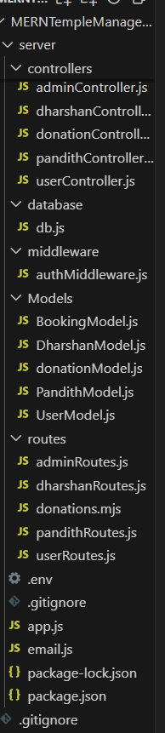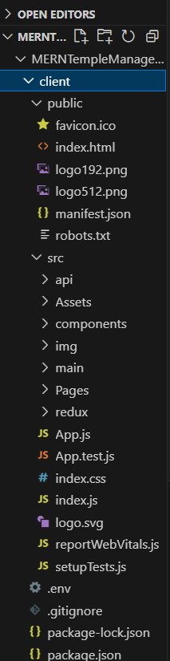 **CLIENT SERVER**

# **5.1 CLIENT:**

**Frontend (React):**

Components: Organize reusable parts of the user interface.

Dashboard: Displays key metrics (like temple events, donations, bookings) in an overview format.

User Profile: Contains user details, contribution history, and personal information.

Event Management: Allows admins to create, update, or remove events and display them on the main interface.

Donations: Lets users donate online, view donation history, and get receipts.

Bookings: Manages room or temple services booking, including booking status.

Notifications: Shows updates on upcoming events or booking confirmations.

Admin Panel: Provides access to user management, event creation, and viewing of financial contributions.

Pages:

Home: The landing page with temple information, upcoming events, and announcements.

Events: A list of temple events with details and options to register or RSVP.

Donation Page: A page where users can donate, linked to payment integration (like PayPal or Stripe).

Booking Page: Provides forms for booking temple facilities or services.

Login/Signup: User authentication pages for login and registration.

State Management:

Use Redux or Context API to manage global state (user info, login status, etc.) across components.

API Integration:

Axios or Fetch is used to communicate with the backend for real-time data (events, donations, user profile updates, etc.).

**5.2 SERVER:**

**API Routes:**

/auth: Handles user login, registration, and JWT authentication.

# / event details like name, date, location, and description.

# Donation Model: Records donation details (user, amount, date).

# Booking Model: Manages booking details, including user, booking type, and status.

# **Middleware:**

Authentication Middleware: Secures routes to ensure only logged-in users or admins can access them

Error Handling Middleware: Standardized error responses for various errors.

**Database (MongoDB):**

# Collections:

# Users: Holds all user data and roles.

Events: Stores event information and scheduling.

Donations: Records each donation transaction.

Bookings: Manages all booking requests and statuses.

**Additional Features:**

Notifications System: Push notifications for upcoming events, booking updates, and donation receipts.

**Admin Dashboard:** Gives insights into donations, event attendance, and user management.

This structure helps modularize the application, enabling easy maintenance and scalability as the temple’s digital needs grow. The MERN stack provides a flexible environment for future updates, such as adding new features or improving user experience.

**6. RUNNING THE APPLICATION**

To run the Darshan Ease application locally, you need to start both the frontend and backend servers. Follow the commands below:

**6.1 BACKEND SERVER:**

1. Start the Backend Server

1. Open your terminal (or command prompt).

2. Navigate to the backend directory:

cd path/to/darshan-ease/backend

Replace path/to/darshan-ease with the actual path to your cloned project.

3. Start the backend server using the following command:

npm start

The backend server should now be running on <http://localhost:4000>.

**6.2 FRONTEND SERVER:**

1. Open a new terminal window.

2. Navigate to the frontend directory:

cd path/to/darshan-ease/frontend

Again, replace path/to/darshan-ease with the actual path to your cloned project.

3. Start the frontend application with the following command:

npm start

# **Summary Of Commands**:

Backend:

cd path/to/darshan-ease/backend

npm start

Frontend:

cd path/to/darshan-ease/frontend

npm start

Once both servers are running, you can access the application by opening your web browser and navigating to http://localhost:4000. If you need to stop the servers at any time, you can do so by pressing Ctrl + C in the terminal windows where the servers are running.

The frontend application should now be running on http://localhost:4000.

# **7. API DOCUMENTATION**

The Darshan Ease application exposes several RESTful API endpoints for frontend-backend communication. Below is the documentation detailing each endpoint, including request methods, parameters, and example responses.

Base URL

Backend URL: <http://localhost:5000>

**1. User Endpoints:**

1.1 Register a New User

Endpoint: /api/users/register

Method: POST

Request Body:

{

"username": "string",

"password": "string",

"email": "string"

}

Example Response:

Status: 201 Created

Body:

{

"message": "User registered successfully.",

"user": {

"_id": "userId",

"username": "string",

"email": "string"

}

}

1.2 User Login

Endpoint: /api/users/login

Method: POST

Request Body:

{

"username": "string",

"password": "string"

}

Example Response:

Status: 200 OK

Body:

{

"message": "Login successful.",

"token": "jwt_token"

}

1.3 Get User Profile

Endpoint: /api/users/:id

Method: GET

Parameters:

id: User ID

Example Response:

Status: 200 OK

Body:

{

"_id": "userId",

"username": "string",

"email": "string",

"bookings": []

}

1.4 Update User Profile

Endpoint: /api/users/:id

Method: PUT

Parameters:

id: User ID

Request Body:

{

"username": "string",

"email": "string"

}

Example Response:

Status: 200 OK

Body:

{

"message": "User updated successfully."

}

**2. Temple Endpoints:**

2.1 Get All Temples

Endpoint: /api/temples

Method: GET

Example Response:

Status: 200 OK

Body:

[

{

"_id": "templeId",

"name": "string",

"location": "string",

"operatingHours": "string",

"services": ["Pooja", "Darshanam"]

}

]

**3. Booking Endpoints:**

3.1 Create a New Booking

Endpoint: /api/bookings

Method: POST

Request Body:

{

"userId": "userId",

"templeId": "templeId",

"serviceType": "string",

"date": "YYYY-MM-DD",

"time": "HH:mm",

"status": "pending"

}

Example Response:

Status: 201 Created

Body:

{

"message": "Booking created successfully.",

"booking": {

"_id": "bookingId",

"userId": "userId",

"templeId": "templeId",

"serviceType": "string",

"date": "YYYY-MM-DD",

"time": "HH:mm",

"status": "pending"

}

}

3.2 Get All Bookings for a User

Endpoint: /api/bookings/user/:userId

Method: GET

Parameters:

userId: User ID

Example Response:

Status: 200 OK

Body:

[

{

"_id": "bookingId",

"templeId": "templeId",

"serviceType": "string",

"date": "YYYY-MM-DD",

"time": "HH:mm",

"status": "pending"

}

]

3.3 Cancel a Booking

Endpoint: /api/bookings/:id

Method: DELETE

Parameters:

id: Booking ID

Example Response:

Status: 200 OK

Body:

{

"message": "Booking canceled successfully."

}

**4. Pandit Endpoints:**

4.1 Get All Pandits

Endpoint: /api/pandits

Method: GET

Example Response:

Status: 200 OK

Body:

[

{

"_id": "panditId",

"name": "string",

"specialization": "string",

"availability": ["date1", "date2"]

}

]

**4.2 Book a Pandit**

Endpoint: /api/pandits/book

Method: POST

Request Body:

{

"userId": "userId",

"panditId": "panditId",

"bookingDate": "YYYY-MM-DD"

}

Example Response:

Status: 201 Created

Body:

{

"message": "Pandit booked successfully.",

"booking": {

"_id": "bookingId",

"userId": "userId",

"panditId": "panditId",

"bookingDate": "YYYY-MM-DD"

    }

}

# **8. AUTHENTICATION**

To implement user authentication and authorization, we'll need to create a login and registration system. Users should be able to sign up for an account, enter their personal information, and create a username and password. Once they've registered, they should be able to log in and access the website's features. To secure the website, we can use JWT to authenticate users and control access to sensitive data. When a user logs in, the server will generate a JWT token containing their user ID and any relevant permissions. This token can then be sent to the client-side and stored in a cookie or local storage. On subsequent requests, the client-side will send the token to the server, which will use it to verify the user's identity and grant access to protected routes.By implementing user authentication and authorization, we can ensure that only authorized users can access sensitive data on our e-book website. This helps to protect user privacy and prevent unauthorized access to personal information or payment details.

**Here's an example of a server-side route for logging in a user:**

**javascript code :**

const express = require('express');

const router = express.Router();

const User = require('../models/user');

const jwt = require('jsonwebtoken');

const bcrypt = require('bcryptjs');

router.post('/login', (req, res) => {

const { email, password } = req.body;

User.findOne({ email })

then(user => {

if (!user) {

return res.status(400).json({ msg: 'Invalid Credentials' });

}

bcrypt.compare(password, user.password)

.then(isMatch => {

if (!isMatch) {

return res.status(400).json({ msg: 'Invalid Credentials' });

}

const payload = {

user: {

: user.id

}

};

jwt.sign(

payload,

process.env.JWT_SECRET,

{ expiresIn: 3600 },42

(err, token) => {

if (err) throw err;

res.json({ token });

}

);

});

})

.catch(err => {

console.log(err);

res.status(500).send('Server Error');

});

});

module.exports = router;

**9. USER INTERFACE**

Designing the user interface using HTML, CSS, and JavaScript is an essential part of building a successful e-book website. The UI should be designed to be user-friendly, responsive, and easy to navigate. With the help of popular UI libraries such as Bootstrap, Material UI, or Ant Design, we can speed up the development process and create a modern and visually appealing design. HTML is used to structure the content of the website and create the layout, while CSS is used to style the UI components, such as fonts, colors, and spacing. JavaScript is used to add interactivity and dynamic functionality to the UI. We should focus on creating a responsive design that adapts to different screen sizes, making it easy for users to browse and purchase books on their desktop, tablet, or mobile device. A userfriendly design that provides clear navigation and easy access to the search bar, categories, and filters can improve the user experience and increase conversion rates. Overall, the UI design should complement the server-side and client-side development, making it easy for users to access the functionality they need while enjoying a visually appealing and user friendly experience.

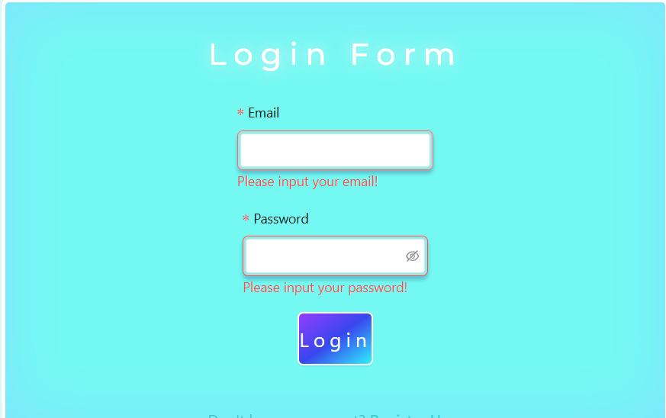

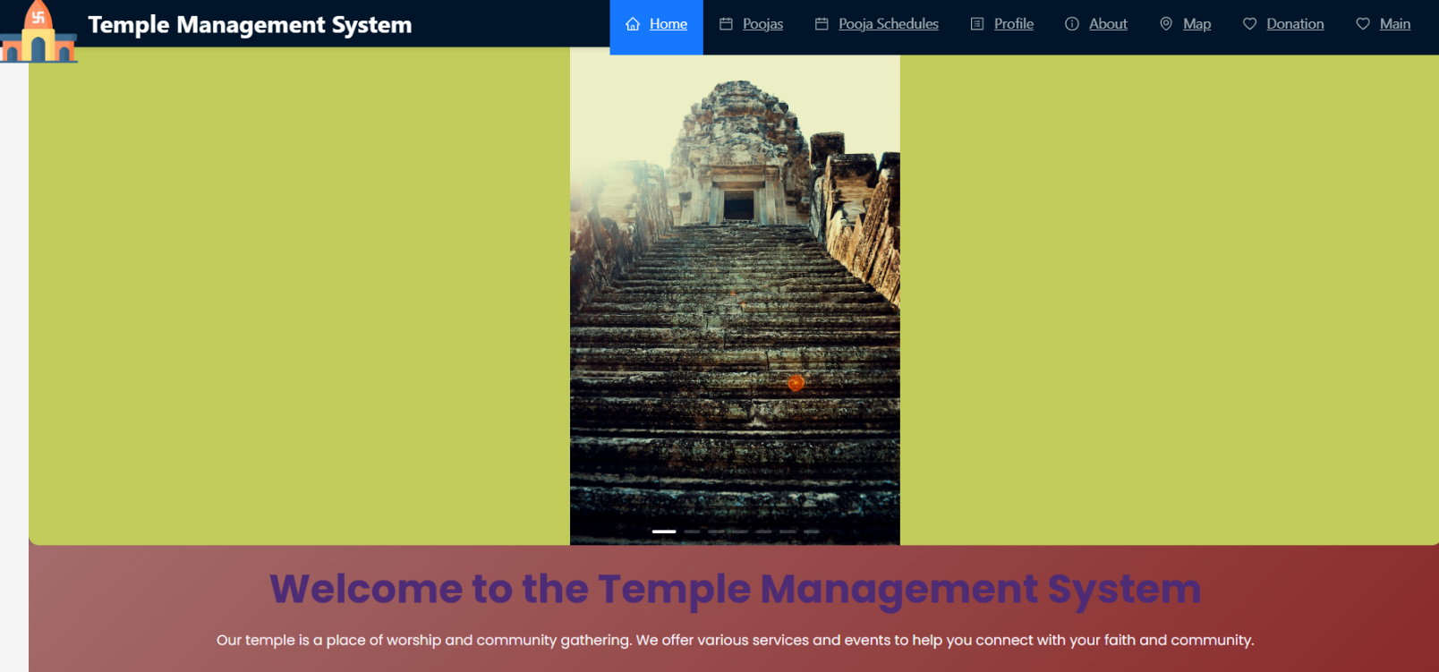

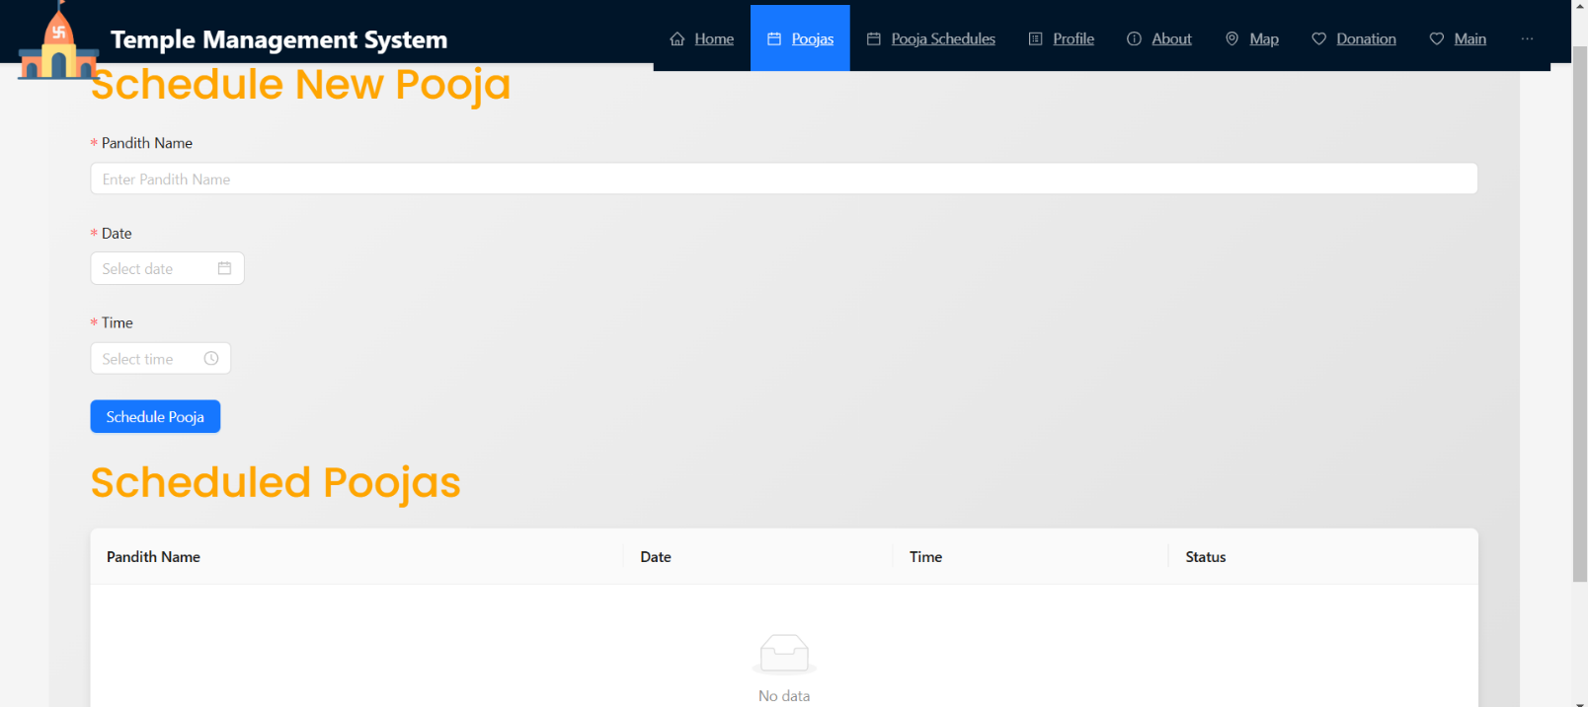

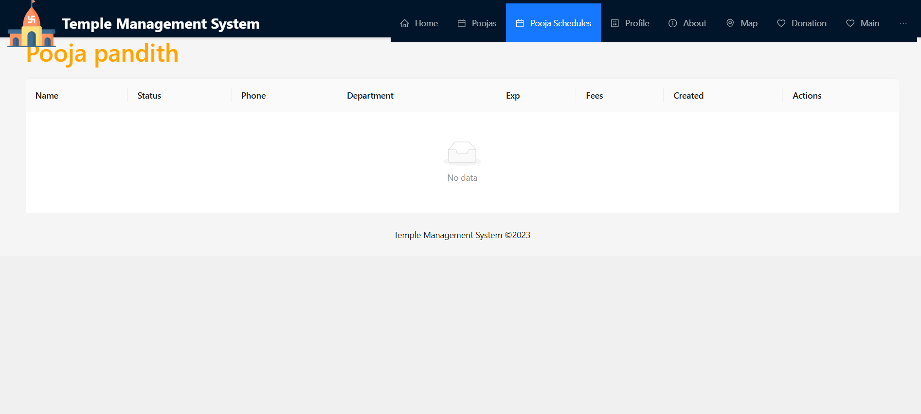

# 

# 

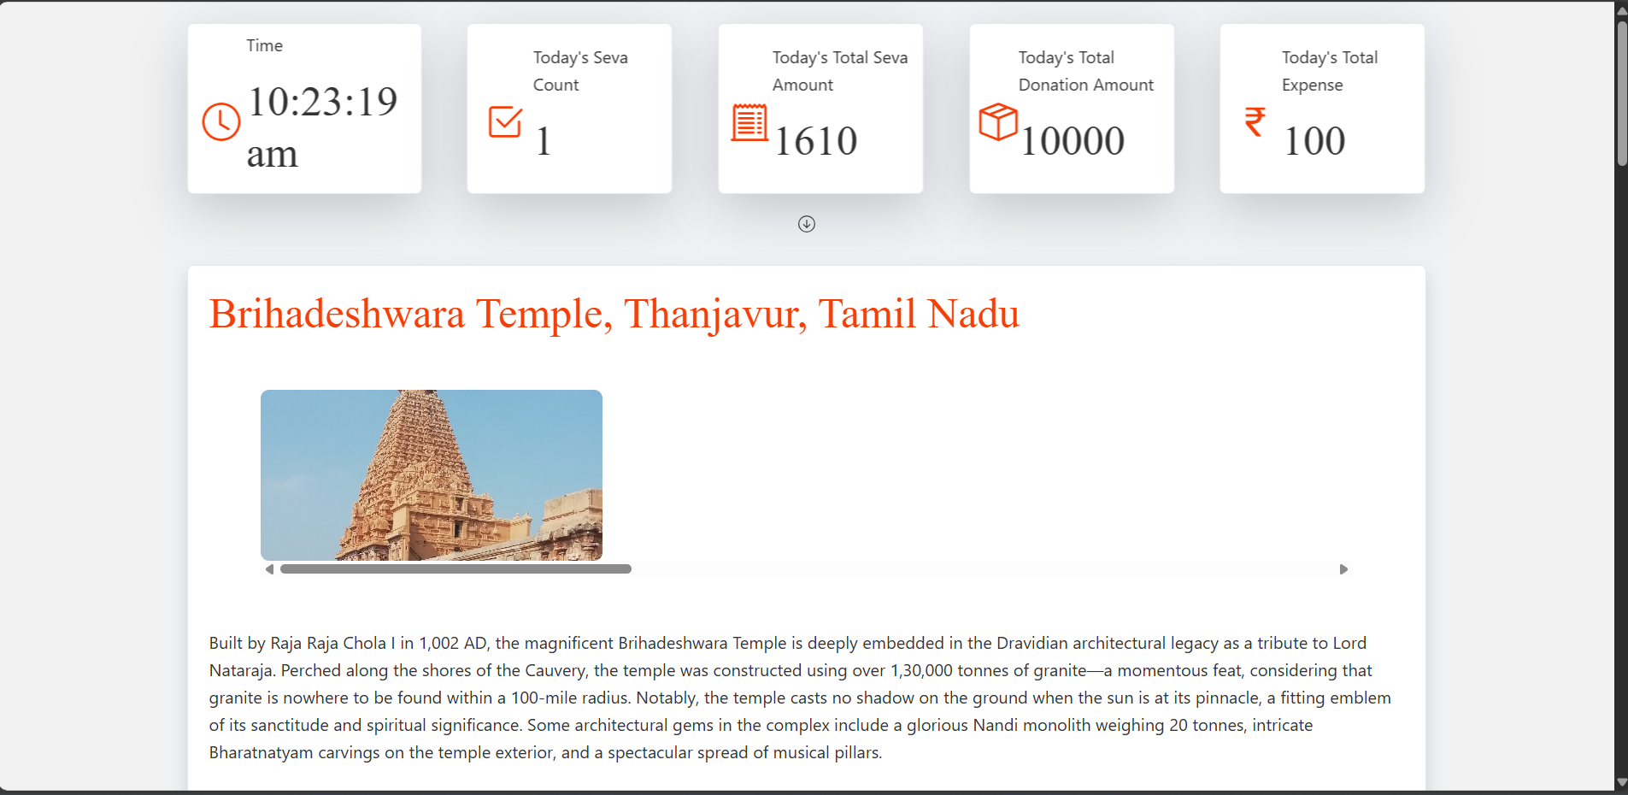

**10.TESTING**

### **SYSTEM TESTING:**

The purpose of testing is to discover errors. Testing is the process of trying to discover every conceivable fault or weakness in a work product. It provides a way to check the functionality of components, sub-assemblies, assemblies and/or a finished product It is the process of exercising software with the intent of ensuring that the Software system meets its requirements and user expectations and does not fail in an unacceptable manner. There are various types of test. Each test type addresses a specific testing requirement.

**TYPES OF TESTS:**

### **Unit testing:**

Unit testing involves the design of test cases that validate that the internal program logic is functioning properly, and that program inputs produce valid outputs. All decision branches and internal code flow should be validated. It is the testing of individual software units of the application .it is done after the completion of an individual unit before integration. This is a structural testing, that relies on knowledge of its construction and is invasive. Unit tests perform basic tests at component level and test a specific business process, application, and/or system configuration. Unit tests ensure that each unique path of a business process performs accurately to the documented specifications and contains clearly defined inputs and expected results.

**Integration testing:**

Integration tests are designed to test integrated software components to determine if they actually run as one program. Testing is event driven and is more concerned with the basic outcome of screens or fields. Integration tests demonstrate that although the components were individually satisfaction, as shown by successfully unit testing, the combination of components is correct and consistent. Integration testing is specifically aimed at exposing the problems that arise from the combination of components.

### **Functional test:**

Functional tests provide systematic demonstrations that functions tested are available as specified by the business and technical requirements, system documentation, and user manuals. Functional testing is centered on the following items:

Valid Input : identified classes of valid input must be accepted.

Invalid Input : identified classes of invalid input must be rejected.

Functions : identified functions must be exercised.

Output : identified classes of application outputs must be exercised. Systems/Procedures: interfacing systems or procedures must be invoked.

Organization and preparation of functional tests is focused on requirements, key functions, or special test cases. In addition, systematic coverage pertaining to identify Business process flows; data fields, predefined processes, and successive processes must be considered for testing. Before functional testing is complete, additional tests are identified and the effective value of current tests is determined.

### **SYSTEM TEST:**

System testing ensures that the entire integrated software system meets requirements. It tests a configuration to ensure known and predictable results. An example of system testing is the configuration-oriented system integration test. System testing is based on process descriptions and flows, emphasizing pre-driven process links and integration points.

### **White Box Testing:**

White Box Testing is a testing in which in which the software tester has knowledge of the inner workings, structure and language of the software, or at least its purpose. It is purpose. It is used to test areas that cannot be reached from a black box level.

### **Black Box Testing:**

Black Box Testing is testing the software without any knowledge of the inner workings, structure or language of the module being tested. Black box tests, as most other kinds of tests, must be written from a definitive source document, such as specification or requirements document, such as specification or requirements document. It is a testing in which the software under test is

treated, as a black box. you cannot “see” into it. The test provides inputs and responds to outputs without considering how the software works.

### **Unit Testing:**

Unit testing is usually conducted as part of a combined code and unit test phase of the software lifecycle, although it is not uncommon for coding and unit testing to be conducted as two distinct phases.

* + Test strategy and approach
  + Field testing will be performed manually and functional tests will be written in detail.

Test objectives

* All field entries must work properly.
* Pages must be activated from the identified link.
* The entry screen, messages and responses must not be delayed. Features to be tested
* Verify that the entries are of the correct format
* No duplicate entries should be allowed
* All links should take the user to the corre

### **Integration Testing:**

Software integration testing is the incremental integration testing of two or more integrated software components on a single platform to produce failures caused by interface defects.

* + The task of the integration test is to check that components or software applications, e.g. components in a software system or – one step up – software applications at the company level – interact without error.

**Test Results**: All the test cases mentioned above passed successfully. No defects encountered.

**11. SCREENSHOTS OR DEMO:**

Github url: https://github.com/SaiVidhya583/MernstackProject.git

**12. KNOWN ISSUESS**

**1. User Authentication and Authorization:**

Issue: Ensuring secure access to certain areas of the application (e.g., admin-only sections) can be challenging. It's crucial to avoid security loopholes that might allow unauthorized access.

Solution: Use JSON Web Tokens (JWT) for session management and securely store tokens. Implement role-based access control (RBAC) to define user permissions clearly.

**2. Data Validation and Sanitization:**

Issue: User input (like registration forms, donation entries, etc.) may contain invalid or malicious data, which can cause issues in the database or lead to security vulnerabilities.

Solution: Use libraries like Joi (for backend validation) and Formik or React Hook Form (for frontend validation). Sanitize input to prevent injection attacks.

**3. Database Design and Performance:**

Issue: A poorly designed schema may result in slow queries, especially for reporting or analytics functions (like viewing historical donations).

Solution: Carefully design the schema to normalize data where appropriate, and use indexes on frequently queried fields. Consider MongoDB's aggregation framework for complex data retrieval.

**4. File Uploads (e.g., Photos, Documents):**

Issue: Temples often store event photos, donation receipts, and other documents, which can lead to issues with storage, server load, and performance.

Solution: Use a cloud storage solution like AWS S3 or Firebase Storage for large files and store only the URLs in MongoDB. Handle file size limitations and optimize image uploads.

**5. Real-Time Updates for Events or Announcements:**

Issue: Updating users with real-time information about events or schedules can be challenging to implement efficiently.

Solution: Use WebSockets (e.g., Socket.io) or server-sent events (SSE) for real-time communication. Alternatively, consider a push-notification solution for mobile devices.

**6. Role Management for Temple Admins and Volunteers:**

Issue: Some users may need different levels of access or permissions within the app (e.g., only temple admins can create events, while volunteers can view schedules).

Solution: Use a role-based access model and define routes and React components that render conditionally based on user roles. Store roles in the database and verify permissions on both the backend and frontend.

**7. Payment Gateway Integration for Donations:**

Issue: Integrating payment gateways can be tricky due to API inconsistencies, transaction security, and ensuring proper record-keeping in MongoDB.

Solution: Use secure payment providers (like Stripe or Razorpay). Implement secure payment flow with encryption and error handling for failed or canceled payments.

**8. Responsive Design for User Accessibility :**

Issue: Many users may access the application on mobile devices, requiring a responsive layout that adapts well to different screen sizes.

Solution: Use CSS frameworks like Bootstrap or Material-UI and test the UI across various screen sizes to ensure accessibility and usability.

**9. Error Handling and Logging :**

Issue: Errors in data fetching or user interactions can lead to a poor user experience. Additionally, debugging issues in production without proper logging can be difficult.

Solution: Use a centralized error-handling middleware in Express, and add try-catch blocks in the API routes and components. For logging, consider services like Winston or an error-tracking service like Sentry.

**10. Scalability and Performance Optimization:**

Issue: As the number of users grows, server load can increase, slowing down response times

**13. FUTURE ENHANCEMENTS**

The Temple Management System has significant potential for future enhancements and expansions, including:

**Mobile Application Development:** Creating a dedicated mobile app for iOS and Android platforms to increase accessibility and user engagement, allowing devotees to manage activities and donations seamlessly on their mobile devices.

**Enhanced Analytics**: Implementing advanced data analytics and reporting tools to provide insights into temple activities, donation patterns, and user engagement, helping administrators make informed decisions.

**Integration with IoT Devices**: Utilizing IoT technology to monitor temple facilities, such as energy usage and security systems, facilitating better resource management and operational efficiency.

**Multi-language Support**: Expanding the system's reach by incorporating multiple language options to cater to a diverse user base, enhancing inclusivity.

**Event Management Features**: Adding features for managing events such as festivals and ceremonies, including registration, scheduling, and communication tools for attendees.

**AI Chatbot Integration**: Implementing an AI-powered chatbot for 24/7 user support, providing instant assistance with queries related to temple services and events.

**Blockchain for Transparency**: Exploring the use of blockchain technology to enhance transparency and security in financial transactions, ensuring trust in donation processes.

**Community Engagement Tool**s: Developing forums and social features to encourage community interaction, sharing of experiences, and participation in temple activities.

These enhancements will ensure that the Temple Management System remains relevant and continues to serve the community effectively while adapting to technological advancements and user needs.